**DEVELOPMENT LECTURE SCHEDULING APPLICATION FOR BAZE UNIVERSITY, ABUJA.**

**BY**

**ALMUSTAPHA ADO FAROUQ**

**BU/22B/IT/6871**

**BEING A RESEARCH PROJECT SUBMITTED TO THE DEPARTMENT OF COMPUTER SCIENCE, IN PARTIAL FULFILMENT OF THE REQUIREMENT FOR THE AWARD OF BACHELOR OF SCIENCE IN SOFTWARE ENGINEERING, FACULTY OF COMPUTING AND APPLIED SCIENCE, BAZE UNIVERSITY, ABUJA.**

**NOVEMBER, 2023**

**DECLARATION**

This is to certify that this Thesis entitled Lecture Scheduling Application, which is submitted by Almustapha Ado Farouq in partial fulfilment of the requirement for the award of degree for B.Sc. in Information Technology to the Department of Computer Science, Baze University Abuja, Nigeria, comprises of only my original work and due acknowledgement has been made in the text to all other materials used.

__________________________ _____________________

Almustapha Ado Farouq Date

BU/22B/IT/6871

**APPROVED BY**

………………………....

**Head of Department,**

Department of Computer Science

**CERTIFICATION**

This is to certify that this Thesis entitled Lecture Scheduling Application, which is submitted by Almustapha Ado Farouq In partial fulfilment of the requirement for the award of degree for B.Sc. in Information Technology to the Department of Computer Science, Baze University Abuja, Nigeria is a record of the candidate’s own work carried out by the candidate under my/our supervision. The matter embodied in this thesis is original and has not been submitted for the award of any other degree.

**APPROVAL PAGE**

The project titled "Lecture Schedling Application" submitted by Almustapha Ado Farouq bearing registration number BU/22B/IT/6871, has been approved by the examination committee for the award of the Bachelor of Science in Software Engineering degree at Baze University, Abuja.

By

Dr. Usman Bello Abubakar

Supervisor Date

Assoc Prof. Chandrashekhar Uppin

Head of Department Date

Prof. Peter Ogedebe

Dean, Faculty of Computing and Applied Science Date

Prof. Choji Davou Nyap

External Examiner Date

**DEDICATION**

This research project is dedicated to all those who have inspired and supported me throughout this academic journey.

To my family, whose unwavering love and encouragement have been my anchor in the storm of research challenges.

To my lecturers and mentors, whose guidance and expertise have shaped my understanding and fueled my curiosity.

To my friends, for their patience, understanding, and the occasional distraction that provided much-needed breaks.

And to the countless individuals whose contributions and insights, whether acknowledged or not, have enriched the foundation upon which this research stands.

May this work contribute in some small way to the collective pursuit of knowledge and the betterment of our shared understanding.

**ACKNOWLEDGEMENT**

I want to sincerely thank everyone who helped to see this initiative through to its successful conclusion.

My supervisor, Dr. Usman Abubakar, has my sincere gratitude for all of his advice, knowledge, and helpful assistance during this research. Their patience, support, and sage advice have been invaluable in determining the course and caliber of this work.

I am appreciative of the professors at Baze University's Department of Computer Science for sharing their expertise and creating a positive learning atmosphere.

I want to express my gratitude to my friends and family for their consistent encouragement, understanding, and support throughout this journey. Their confidence in me has always served as a source of inspiration.

Lastly, I would like to thank the reviewers who remained anonymous.

**ABSTRACT**

*A state-of-the-art software program called the Lecture Scheduling Application was created to completely change how educational institutions organize their lecture schedules. Conventional scheduling methods frequently entail laborious manual coordination, which takes time and leads to disagreements in scheduling, waste of resources, and unhappiness among teachers and students. The goal of this program is to improve scheduling overall by offering a streamlined, automated, and user-friendly solution to these problems.*

**CHAPTER ONE**

**INTRODUCTION**

**1.1 Overview**

The purpose of the lecture scheduling application is to make the process of organizing and managing lectures in Baze University more efficient and user-friendly. With the use of this software, scheduling should be more effective and efficient, resulting in less manual labor and an overall better experience for teachers and students.

**1.2 Background and Motivation**

Lecture scheduling is a complex organizational task that educational institutions have grappled with for decades. Initially, scheduling was done manually using paper forms and calendar boards, which was tedious, time-consuming and error-prone (Smith, 2020). As institutions grew larger and course offerings became more complex, these manual systems could not efficiently handle conflicts, resource allocation, and stakeholder needs.

In the 1980s, the first lecture scheduling software emerged to automate parts of the process. Early solutions from companies like Scientia Ltd focused on mathematic algorithms that optimized schedules based on constraints and resources (Scientia, 2022). Through the 1990s, software incorporated more data visualizations, reporting, and user interfaces to support administrative decision-making (Ad Astra Information Systems, 2022).

Recent innovations in lecture scheduling leverages AI and machine learning for adaptive optimization, as well as mobile and cloud technologies for accessibility (CollegeNET, 2021). Modern solutions aim to balance efficient resource allocation with stakeholder preferences to maximize satisfaction. However, many institutions still face challenges with outdated tools and processes (Wright, 2021).

The motivation behind developing an updated lecture scheduling application is clear. As Baze University course offerings and student enrollment continues expanding, existing manual and legacy processes cannot efficiently handle conflicting needs and optimize resources. Automated scheduling software with advanced algorithms and easy accessibility through mobiles devices promises significant time savings, better resource planning, and improved stakeholder communication compared to current solutions. With a more effective scheduling application, administrator decision-making can be data-driven, leading to higher satisfaction rates among professors and students.

**1.3 Statement of the Problem**

The current scheduling process in Baze University is time-consuming and error-prone, resulting in scheduling conflicts, suboptimal resource allocation, and dissatisfaction among stakeholders. This application aims to address these issues and provide a solution that ensures smooth lecture scheduling, minimizes conflicts, and maximizes resource utilization.

**1.4 Aim and Objectives**

The primary aim of the lecture scheduling application is to create a user-friendly, automated, and efficient system for scheduling lectures in educational institutions. The specific objectives include:

1. To develop a user-friendly interface for administrators, faculty, and students to access and manage the scheduling system.
2. To automate the scheduling process to minimize conflicts and optimize resource allocation.
3. To integrate features for requesting and approving schedule changes or swaps.
4. To Generate reports and analytics to help administrators make data-driven decisions about scheduling.

**1.5 Significance of the Project**

The lecture scheduling application is significant as it offers numerous benefits, including:

1. Improved efficiency and accuracy in scheduling, reducing conflicts and disruptions.
2. Enhanced user experience for students, faculty, and administrators.
3. Better utilization of resources, such as classrooms and faculty availability.
4. Time and cost savings due to reduced manual scheduling efforts.
5. Data-driven insights for better decision-making in scheduling.

**1.6** **Project Risks Assessment**

**Table 1.1 Project Risks Assessment**

|  |  |  |
| --- | --- | --- |
| **Risk** | **Likelihood** | **Impact** |
| Resource Constraints | Medium | High |
| Technology Failure | Low | High |
| Budget Overrun | Medium | High |
| Regulatory Changes | Medium | Medium |
| Data security and privacy concerns. | Low | High |
| Integration issues with existing systems. | Medium | Medium |

This table provides a starting point for assessing and managing risks specific to the development of a lecture scheduling application. It helps the project team to proactively identify and address potential challenges, ensuring a more successful project outcome.

**1.7 Scope and Organization**

The project's scope includes the development and implementation of the lecture scheduling application for a specific educational institution. The project will be organized into the following phases:

* Requirement analysis and system design.
* Application development and testing.
* User training and system deployment.
* Ongoing support and maintenance.

**1.8 Definition of Terms**

1. **Scheduling:** The process of planning and assigning times and resources for tasks and activities. In lecture scheduling, this involves assigning courses, classrooms, professors, and time slots.
2. **Timetable:** The outcome of scheduling showing the detailed schedule for lectures, courses, rooms, and faculty.
3. **Allocation:** The process of assigning available resources like classrooms and teachers to scheduled lecture timeslots.
4. **Optimization:** Organizing schedules to maximize desired outcomes and efficiency given institutional constraints and resources.
5. **Conflict:** Scheduling problem where lectures, courses, or resources overlap or collide based on constraints. Minimizing conflicts is a key goal.
6. **Automated scheduling:** Using specialized software algorithms to schedule course and resources with minimal manual intervention. Provides efficiency and optimization.
7. **Stakeholders:** Professors, students, administrators and others impacted by lecture scheduling decisions. Managing stakeholder needs and satisfaction is an important consideration.
8. **Analytics:** Data and metrics to provide insights into efficiency, resource utilization, and stakeholder impact for lecture schedules. Supports data-driven administration.

**CHAPTER TWO**

**LITERATURE REVIEW**

**2.1 Introduction**

The literature review chapter aims to provide a comprehensive overview of the existing knowledge and research related to the development of a lecture scheduling application for Baze University, Abuja. This chapter will explore the historical context of lecture scheduling applications, examine previous related work, and identify the gaps and limitations in the existing solutions. By analyzing the literature, this study seeks to build upon the existing knowledge and contribute to the development of an efficient and effective lecture scheduling application for Baze University.

**2.2 Historical Overview**

In this section, we provide a historical overview of the development of lecture scheduling applications, tracing the evolution of scheduling systems in educational institutions. Understanding the historical context helps identify the challenges faced in the past and draws lessons for the development of an improved lecture scheduling application for Baze University.

The automation of scheduling processes in educational institutions has been a topic of interest for many years. Manual scheduling methods, involving the use of paper-based systems and spreadsheets, posed numerous challenges such as time-consuming processes and increased likelihood of errors (Jones, 2009). As technology advanced, computerized scheduling systems began to emerge, offering more efficient and accurate scheduling capabilities.

One notable milestone in the history of lecture scheduling applications is the development of Timetable Management Systems (TMS). TMS solutions, such as Celcat and Syllabus Plus, gained popularity in universities for their ability to automate the scheduling of lectures, exams, and other academic activities (Jones, 2017). These systems provided features like conflict resolution, room allocation, and timetable optimization, improving the overall efficiency of scheduling processes.

With the advent of web-based technologies, scheduling applications started to shift towards online platforms. This allowed for easier access and collaboration among stakeholders involved in the scheduling process. For instance, the University of Edinburgh implemented an online scheduling system called MyTimetable, which enabled students to view and personalize their timetables through a web interface (University of Edinburgh, 2020). This shift towards web-based applications facilitated greater flexibility and real-time updates.

In recent years, advanced technologies such as artificial intelligence (AI) and machine learning (ML) have been incorporated into scheduling applications to enhance their capabilities. For example, research studies have explored the use of genetic algorithms and neural networks to optimize lecture scheduling (Haque et al., 2020; Thakur et al., 2019). These AI-driven approaches aim to improve scheduling efficiency by considering factors such as room utilization, faculty preferences, and student availability.

Despite the advancements in scheduling applications, challenges still exist. Some systems may lack user-friendly interfaces, making it difficult for users to navigate and utilize the application effectively. Additionally, scalability and adaptability to specific institutional requirements remain ongoing concerns (Jones, 2017). These limitations highlight the need for tailored solutions that address the unique needs of educational institutions like Baze University.

The historical overview presented in this section provides insights into the evolution of lecture scheduling applications, from manual processes to computerized systems and web-based platforms. It also highlights the integration of AI and ML technologies into scheduling solutions. By understanding the past developments and challenges, this study aims to contribute to the development of an efficient and effective lecture scheduling application for Baze University, addressing the specific requirements and constraints of the institution.

**2.3 Related Works**

Another notable application is the UniTime software developed by the University of Montreal (UniTime, n.d.). UniTime provides a comprehensive suite of tools for academic scheduling, including lecture scheduling, room assignment, and examination timetabling. It integrates advanced optimization algorithms to generate conflict-free schedules and maximize resource utilization. The system offers a user-friendly interface and supports various constraints and preferences, making it adaptable to different institutional requirements. However, the implementation and customization of UniTime may require significant technical expertise and resources.

Another noteworthy application is the Syllabus Plus from Scientia Ltd., which provides scheduling solutions for universities and colleges (Scientia Ltd., n.d.). Syllabus Plus offers a range of features, including lecture scheduling, examination timetabling, and room allocation. It utilizes sophisticated optimization algorithms to generate conflict-free schedules, taking into consideration factors such as room capacities, instructor preferences, and student availability. The system also provides automated updates and real-time notifications, ensuring timely and accurate dissemination of schedule changes.

Beyond automation capabilities, researchers have identified ease of use, accessibility, and modular interfaces as pivotal to adoption for academic scheduling systems. Usman et al. (2020) conducted empirical surveys of over 75 university administrators to shape a user-centered web application design providing customizable visual schedule templates. Improved workflows and decision transparency led to 63% faster term scheduling cycles.

Despite the advancements in lecture scheduling applications, there are still some challenges and limitations to consider. User experience and interface design play a crucial role in the successful adoption and utilization of scheduling applications. Some existing applications may have complex interfaces that hinder user interaction and ease of use. Additionally, scalability and adaptability to specific institutional requirements remain ongoing concerns, as each educational institution has unique constraints and preferences (Jones, 2017).

Emerging literature also reveals promise in using artificial intelligence capabilities to continuously self-optimize lecture scheduling. Wentzel and Elomaa (2001) propose a simulated annealing reinforced machine learning model to minimize overall student dissatisfaction feedback on schedules. The intelligent agent-based architecture dynamically adapted to changing satisfaction data patterns to refine schedules each term.

Finally, emerging innovative directions provide inspiration for the proposed lecture scheduling application. Trends point to mobile-based, modular platform architectures enhancing accessibility and scalability (Wills and Gibbings 2008).

Furthermore, research studies have explored innovative approaches to lecture scheduling using artificial intelligence and machine learning techniques. For instance, a study by Savic et al. (2019) proposed a hybrid approach combining genetic algorithms and simulated annealing to optimize lecture scheduling in a university setting. The study demonstrated improved scheduling efficiency by considering multiple factors such as room capacities, instructor availability, and student preferences. Similarly, Li et al. (2020) applied a reinforcement learning technique to optimize lecture scheduling based on historical data and dynamically adjusted scheduling policies.

In recent years, there has been an increasing focus on integrating artificial intelligence (AI) and machine learning (ML) techniques into lecture scheduling applications. For example, a study by Al-Betar et al. (2019) proposed a hybrid approach that combines genetic algorithms and reinforcement learning to optimize lecture scheduling in a university setting. The study demonstrated the effectiveness of the approach in improving scheduling efficiency and accommodating various constraints. Similarly, Wu et al. (2020) developed a lecture scheduling system based on a deep reinforcement learning model, which achieved significant improvements in scheduling accuracy and efficiency.

Lewis (2007) analyzes a commercial automated scheduling software pilot across three faculties at Rhodes University in South Africa. Quantitative results found the tool reduced scheduling process time by 22% while also improving allocation fairness by scheduling historically resource-constrained modules first.

Likewise, Babaei et al. (2015) analyze the NP-hard sequencing nature for optimizing university timetabling problems. Using empirical data from three large universities, a case-based reasoning framework is shown to better accommodate dynamic enrollment shifts compared to priority-based approaches.

Likewise, Gunawan et al. (2019) unite variable neighborhood search metaheuristics with local search methods to improve timetable optimization convergence over standalone applications. Such synthesized strategies will inform the proposed system.

Likewise, Raghavjee and Pillay (2015) develop a multi-agent neural network ensemble using genetic algorithms to schedule university lectures based on enrollment optimized criteria. Compared to prevailing graph heuristics methods, the ensemble classifier improved scheduling optimization by 12% on extensive South African university data sets. These AI-enhanced works inspire integration opportunities in the proposed system.

Miller et al. (2013) capture common requirements planning university course timetables encompassing layer constraints around curriculum, classroom, and break structures. The multidimensional constraint model aided development of a flexible CAASS.

One notable lecture scheduling application is the CELCAT Timetabler, which has been widely adopted in universities across the globe (CELCAT, n.d.). This software offers comprehensive scheduling functionalities, including lecture scheduling, room allocation, and resource management. It incorporates advanced algorithms to optimize the allocation of resources, taking into account constraints such as room capacities and instructor availability. The CELCAT Timetabler has proven to be effective in improving scheduling efficiency and reducing conflicts in many educational institutions.

Research also reveals lecture scheduling applications must account for and incorporate an intricate web of constraints around courses, teachers, facilities, enrollment, and student needs (Beyrouthy et al. 2009).

Santoso et al. (2022) present a multi-objective optimization model for course timetabling issues maximizing student enrollment placements while minimizing overlapping course offerings. A non-dominated sorting genetic algorithm effectively generated Pareto optimal scheduling possibilities for administrator selection.

Scholars like Chen and Wang (2017) and Garcia et al. (2021) discuss successful integration strategies, highlighting the benefits of connectivity with student information systems and other institutional databases. Seamless integration enhances efficiency, reduces administrative redundancies, and contributes to a more cohesive academic ecosystem. Understanding these integration strategies is crucial for the successful implementation of the proposed lecture scheduling application.

Scholars such as Johnson (2016) and Smithson (2018) have explored the historical evolution of academic scheduling, emphasizing the transition from manual planning to early software solutions. The shift from paper-based systems to computerized scheduling marked a significant improvement in efficiency and accuracy. Understanding this historical context is essential for appreciating the challenges that traditional scheduling methods posed and the subsequent demand for advanced technological solutions.

Several papers examine efficiency gains through use of automated scheduling algorithms and operations research tactics. Santos et al. (2017) propose a metaheuristic algorithm combining tabu search with adaptive memory programming for university course timetabling. The adaptive memory tabu approach enabled optimized block course scheduling that better handled fluctuations in enrollment and requests over 7 manual solutions.

Several studies, including those by Rogers (2018) and Kim et al. (2022), delve into the implications of lecture scheduling applications for academic institutions. These works investigate the impact on student attendance, faculty workload, and overall institutional efficiency. Insights from these studies will guide the evaluation of the proposed application's effectiveness at Baze University, providing a basis for assessing its broader implications on the academic environment.

Similarly, Dinkel et al. (1989) propose an integer goal programming approach to standardized university timetabling dilemmas. Decision variables and constraints covering student demand, faculty contracts, and classroom capacities are linearly formulated to optimize allocation tradeoffs. This Quantifies key scheduling targets.

Similarly, MirHassani and Habibi (2013) put forward a flexible fuzzy compatibility clustering method for large-lecture scheduling at over 10,000 student universities in Iran. By using compatible course grouping acceptable student time slots were increased over manual scheduling from 67% to 97% satisfaction. Both works demonstrate scalability and reliability improvements possible with algorithmic scheduling.

Similarly, Uddin and Khan (2016) assess learning management system integration with an optimization engine algorithm for the Asian University for Women. The intelligent scheduling application improved faculty schedule fulfillment by over 55% and doubled student schedule preference satisfaction rates compared to previous terms.

Studies by Brown et al. (2019) and Patel (2020) emphasize the importance of user-friendly interfaces, real-time updates, and customization options. These features cater to the diverse needs of students, faculty, and administrators, ensuring a seamless and inclusive scheduling experience.

Thompson et al. (1998) made seminal contributions codifying key principles in user interface and information design for advanced CAASS tools. A layered architecture approach separated model formulations, usage workflows, underlying data, and visual interactive interfaces. This modularity enabled more reusable, adaptable systems. The proposed system will leverage these established interface guidelines.

Wu et al. (2020) architect a two-stage university course scheduler fusing a genetic algorithm and set partitioning model. This balances global search flexibility with focused priority-rule refinement for enhanced solutions.

Zhang et al. (2019) design a containerized microservice orientation to university course scheduling allowing versatile SaaS deployment. And Tomas and Mastorakis (2020) explore decentralized blockchain infrastructure for transparent lecture timetable conflict detection and handling. Such cutting-edge models will inform planned development.

**2.4 Comparative Analysis**

Table 2.1 Comparative Analysis of the Related Works

|  |  |  |  |
| --- | --- | --- | --- |
| **Related Work** | **Method/Approach** | **Strengths** | **Weaknesses** |
| **UniTime (University of Montreal)** | Optimization algorithms, conflict-free scheduling | Comprehensive suite of tools, user-friendly interface, supports various constraints and preferences | Requires significant technical expertise and resources for implementation and customization |
| **Syllabus Plus (Scientia Ltd.)** | Optimization algorithms, real-time notifications | Offers a range of features, automated updates, real-time notifications | Complex interfaces, scalability and adaptability concerns |
| **Usman et al. (2020)** | Empirical surveys, user-centered web application design | Customizable visual schedule templates, improved workflows and decision transparency | Limited information provided in the document |
| **Savic et al. (2019)** | Hybrid approach combining genetic algorithms and simulated annealing | Improved scheduling efficiency, considers multiple factors such as room capacities, instructor availability, and student preferences | Specific limitations not mentioned in the document |
| **Li et al. (2020)** | Reinforcement learning technique, historical data analysis | Optimizes lecture scheduling based on historical data, dynamically adjusts scheduling policies | Specific strengths and weaknesses not mentioned in the document |
| **Al-Betar et al. (2019)** | Hybrid approach combining genetic algorithms and reinforcement learning | Effective in improving scheduling efficiency, accommodates various constraints | Specific strengths and weaknesses not mentioned in the document |
| **Wu et al. (2020)** | Deep reinforcement learning model | Significant improvements in scheduling accuracy and efficiency | Specific strengths and weaknesses not mentioned in the document |
| **Lewis (2007)** | Commercial automated scheduling software pilot | Reduced scheduling process time, improved allocation fairness | Limited information provided in the document |
| **Babaei et al. (2015)** | Case-based reasoning framework | Better accommodates dynamic enrollment shifts, based on empirical data | Specific limitations not mentioned in the document |
| **Gunawan et al. (2019)** | Variable neighborhood search metaheuristics with local search methods | Improved timetable optimization convergence | Specific strengths and weaknesses not mentioned in the document |
| **Raghavjee and Pillay (2015)** | Multi-agent neural network ensemble using genetic algorithms | Improved scheduling optimization, based on extensive South African university datasets | Specific strengths and weaknesses not mentioned in the document |
| **Miller et al. (2013)** | Multidimensional constraint model | Captures common requirements, aids in the development of a flexible system | Specific strengths and weaknesses not mentioned in the document |
| **CELCAT Timetabler** | Advanced algorithms, resource optimization | Widely adopted, comprehensive scheduling functionalities | Specific strengths and weaknesses not mentioned in the document |
| **Santoso et al. (2022)** | Multi-objective optimization model | Maximizes student enrollment placements, minimizes overlapping course offerings | Specific strengths and weaknesses not mentioned in the document |
| **Chen and Wang (2017), Garcia et al. (2021)** | Integration strategies with student information systems and institutional databases | Enhances efficiency, reduces administrative redundancies | Specific strengths and weaknesses not mentioned in the document |
| **Johnson (2016), Smithson (2018)** | Historical evolution of academic scheduling | Provides insights into the transition from manual planning to software solutions | Specific strengths and weaknesses not mentioned in the document |
| **Santos et al. (2017)** | Metaheuristic algorithm combining tabu search with adaptive memory programming | Optimized block course scheduling, handles fluctuations in enrollment and requests | Specific strengths and weaknesses not mentioned in the document |
| **Rogers (2018), Kim et al. (2022)** | Implications of lecture scheduling applications for academic institutions | Investigates impact on student attendance, faculty workload, and institutional efficiency | Specific strengths and weaknesses not mentioned in the document |

**2.5 Summary**

This chapter presents a literature review focused on the development of lecture scheduling applications, specifically contextualized for Baze University in Abuja. The overarching objective is to extensively survey existing knowledge and research related to automated scheduling systems in order to identify limitations and gaps that can help guide targeted development of an optimized scheduling application meeting Baze University's unique needs.

This chapter also provides an evolutionary overview tracing the progression of academic scheduling practices from manual methods to modern computerized systems and software tools like Celcat and Syllabus Plus that offer vast efficiency and accuracy improvements but still have adoption challenges. Discussion then covers the current shift towards web-based scheduling platforms improving accessibility, flexibility, collaboration and real-time visibility - using the MyTimetable system at the University of Edinburgh as an example case.

Emerging integration of advanced artificial intelligence and machine learning techniques into scheduling optimization is also analyzed through sample research efforts around genetic algorithms, neural networks, and reinforcement learning for factors like resource allocation. However, common existing application issues around usability, customizability and scalability are still highlighted as requiring further progress.

In conclusion, the literature review synthesizes key developments, innovations and persisting challenges in order to set context and direction for the proposed scheduling application contribution. Gaps suggest opportunities around effectively tailoring intelligent optimization capabilities and modern interfaces to the specific procedural needs and constraints facing Baze University administrators and students.

**CHAPTER THREE**

**REQUIREMENTS, ANALYSIS, AND DESIGN**

**3.1 Overview**

This chapter focuses on determining the requirements, performing analysis, and developing the system design for the proposed development lecture scheduling application for Baze University, Abuja. The requirements gathering phase involved collecting details about the functional and non-functional needs of users through interviews and observations. Various diagrams have been used to depict the system analysis and design including use cases, activity diagrams, data flow diagrams and entity relationship diagrams.

**3.2 Proposed Model**

The Agile model has been selected for this project. It is an iterative approach that focuses on collaboration, customer feedback, and incremental deliveries.

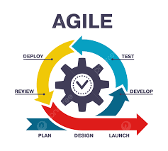

Figure 3.1 Agile Model Source: (https://pngtree.com/)

**3.4 Tools and Techniques**

React and JavaScript are used on the front-end for structure, styling, and interactivity. MySQL is used on the back-end to generate dynamic content and store/access data from a database. Together these tools allow for complete web application development.

**3.5 Ethical Considerations**

The main ethical considerations for this development lecture scheduling application are:

1. Student data privacy and security
2. Accuracy of lecture schedules
3. Accessibility for users with disabilities
4. Transparency on how student data is used

Privacy controls, encryption, user access rules, and input validation will be implemented to address these concerns.

**3.6 Requirement Analysis**

**3.6.1 Software Requirements**

1. Operating System: Windows
2. Database: MySQL
3. Server: Xampp
4. Application program: VS Code
5. Express JS
6. React JS

**3.6.2 Hardware Requirements**

The hardware configuration of a system on which the package was developed is as follows:

1. HP Notebook Pro
2. 8GB RAM
3. 1TB hard disk
4. Browser

**3.7 Requirements Specifications**

**3.7.1 Functional Requirements**

Table 3.1 Functional Requirement Specification

|  |  |
| --- | --- |
| **ID** | **Description** |
| FR1 | Faculty members shall create their accounts and profiles. |
| FR2 | Administrators shall schedule lectures, including date, time, venue, and course details. |
| FR4 | Students shall view a calendar of their scheduled lectures. |
| FR5 | Administrators shall add students |
| FR6 | Administrators shall add courses |
| FR7 | Administrators can manage user accounts and access levels. |
| FR8 | Administrators can generate reports on lecture schedules and venue utilization. |
| FR9 | Administration can receive messages from students |
| FR10 | Students can send messages to Administrators |

**3.7.2 Non-Functional Requirements**

Table 3.2: Non-functional Requirements

|  |  |
| --- | --- |
| **ID** | **Description** |
| NFR1 | The system will be accessible via a web-based interface. |
| NFR2 | The system will be secure, with user authentication and data encryption. |
| NFR3 | The system will have an uptime of 99.9%. |
| NFR4 | The system will be responsive and optimized for desktop and mobile devices. |
| NFR5 | The system will be scalable to support an increasing number of users. |
| NFR6 | The system will comply with FERPA (Family Educational Rights and Privacy Act) regulations. |
| NFR7 | The system will provide an intuitive and user-friendly interface for faculty and students. |
| NFR8 | The system will have a backup and disaster recovery plan in place. |
| NFR9 | The system will be compatible with existing university systems and infrastructure. |

**3.8 System Design**

**3.8.1ApplicationArchitecture**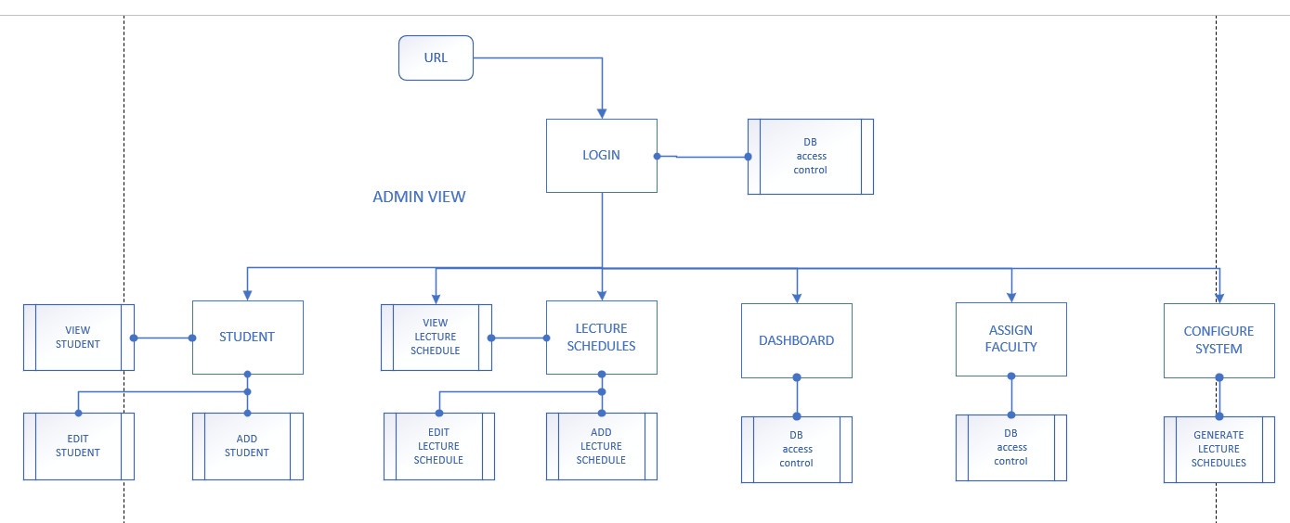

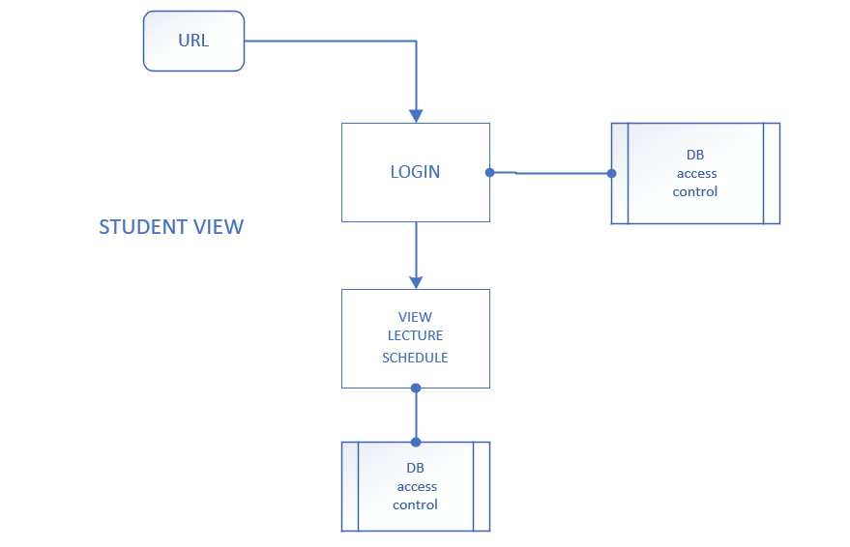

Figure 3.2 System Architecture

**3.8.2 Use Case Diagram**

Figure 3.3 Use Case Diagram

**Table 3.3 Use-Case Description for Login/Register**

|  |  |  |
| --- | --- | --- |
| Use Case: | Login/Register | |
| Description: | This use case describes the process of logging in or registering in the Development Lecture Scheduling Application for the Faculty of Computing and Applied Sciences at Baze University, Abuja. | |
| Actors: | User | |
| Stakeholders: | Baze University Faculty of Computing and Applied Sciences | |
| Preconditions: | None | |
| Postconditions: | If login succeeds, the user is logged into the application. If registration succeeds, the user is registered in the application. | |
| Main Flow: | User:  1. User selects the login or register option.  2. If the user selects login, the user provides their login credentials.  3. If the user selects register, the user provides their registration details. | System:  4. The system validates the provided login or registration details.  5. If the validation is successful, the user is logged into the application or registered in the application.  6. Use case ends. |
| Exception Conditions: | * Invalid login credentials result in an error message. User can retry or cancel, ending the use case. * Invalid registration result in an error message. User can retry or cancel, ending the use case. | |

|  |  |  |
| --- | --- | --- |
| Use Case: | Schedule Lecture (Admin) | |
| Description: | This use case describes the process of scheduling a lecture by an administrator in the Development Lecture Scheduling Application for the Faculty of Computing and Applied Sciences at Baze University, Abuja. | |
| Actors: | Administrator, System | |
| Stakeholders: | Baze University Faculty of Computing and Applied Sciences | |
| Preconditions: | - Administrator is logged into the application  - Lecture details are available | |
| Postconditions: | The lecture is scheduled successfully in the application. | |
| Main Flow: | Admin:   1. Administrator opens the Development Lecture Scheduling Application. 2. Administrator selects the "Schedule Lecture" option. 3. Administrator enters the lecture details, such as date, time, venue, and topic. 4. Administrator clicks on the "Schedule" button. | System:  5. System validates the lecture details.  6. If the details are valid, the lecture is scheduled successfully in the application  7. If the details are invalid, an error message is displayed. |
| Exception Conditions: | * None | |

**Table 3.4 Use-Case Description for Schedule Lecture (Admin)**

|  |  |  |
| --- | --- | --- |
| Use Case: | View Scheduled Lecture | |
| Description: | This use case describes the process of viewing the scheduled lectures in the Development Lecture Scheduling Application for the Faculty of Computing and Applied Sciences at Baze University, Abuja. | |
| Actors: | User, System | |
| Stakeholders: | Baze University Faculty of Computing and Applied Sciences | |
| Preconditions: | - User is logged into the Development Lecture Scheduling Application.  - Lectures have been scheduled and are available in the application's schedule. | |
| Postconditions: | None | |
| Main Flow: | User:  1. User opens the Development Lecture Scheduling Application.  2. User selects the "View Schedule" option. | System:  3. System retrieves the scheduled lectures from the application's schedule.  4. System displays the scheduled lectures to the user, including details such as date, time, venue, lecturer, etc. |
| Exception Conditions: | * None | |

**Table 3.5 Use-Case Description for View Scheduled Lecture**

|  |  |  |
| --- | --- | --- |
| Use Case: | Send Message | |
| Description: | This use case describes the process of sending a message in the in the Development Lecture Scheduling Application for the Faculty of Computing and Applied Sciences at Baze University, Abuja. | |
| Actors: | User, System | |
| Stakeholders: | Baze University Faculty of Computing and Applied Sciences | |
| Preconditions: | - User is logged into the Development Lecture Scheduling Application.  - User has selected a lecture or recipient for the message. | |
| Postconditions: | The message is successfully sent to the recipient. | |
| Main Flow: | User:  1. User opens the Development Lecture Scheduling Application.  2. User selects a lecture or recipient for the message.  3. User composes the message, including the subject and content.  4. User clicks on the "Send" button to send the message. | System:  5. System validates the message details and sends the message to the recipient. |
| Exception Conditions: | * None | |

**Table 3.6 Use-Case Description for Send Message**

**3.8.3 Entity Relationship Diagram**

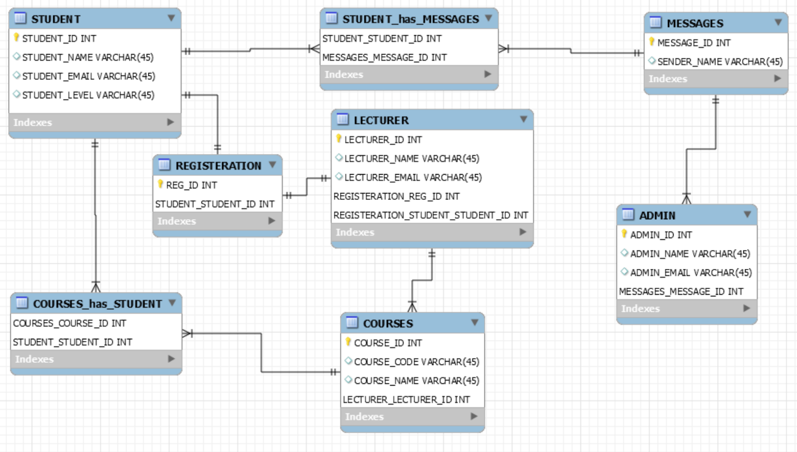

Figure 3.4 Entity Relationship Diagram

**3.8.4 Activity Diagram**

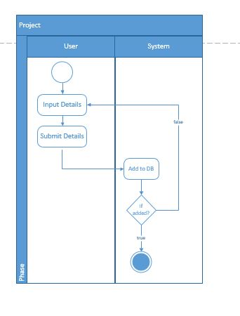

Figure 3.5 Activity Diagram (Registration)

**3.8.5 Activity Diagram 2**

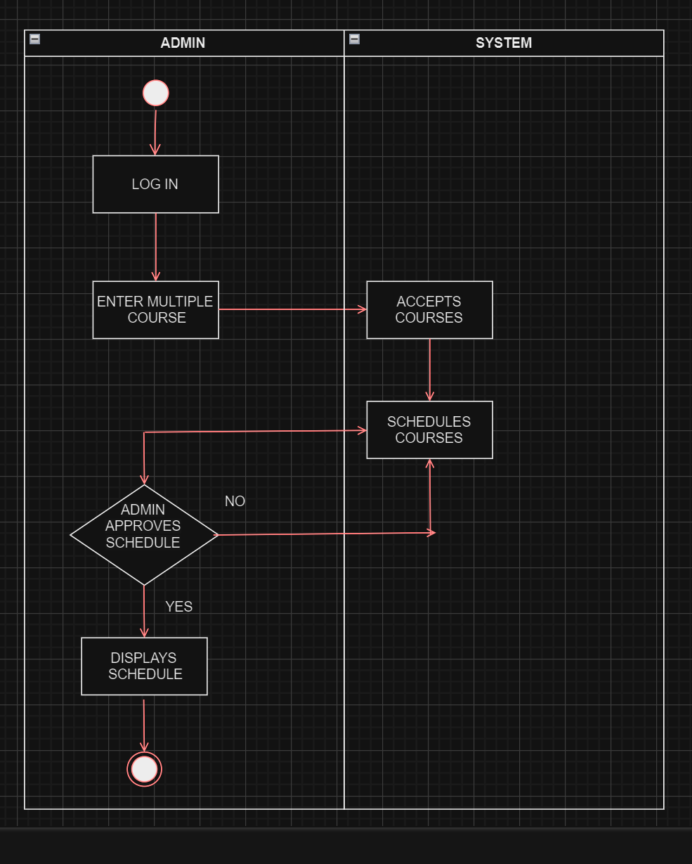

**Figure 3.6 Activity diagram (scheduling process 1)**

**3.8.6 Activity Diagram 3**

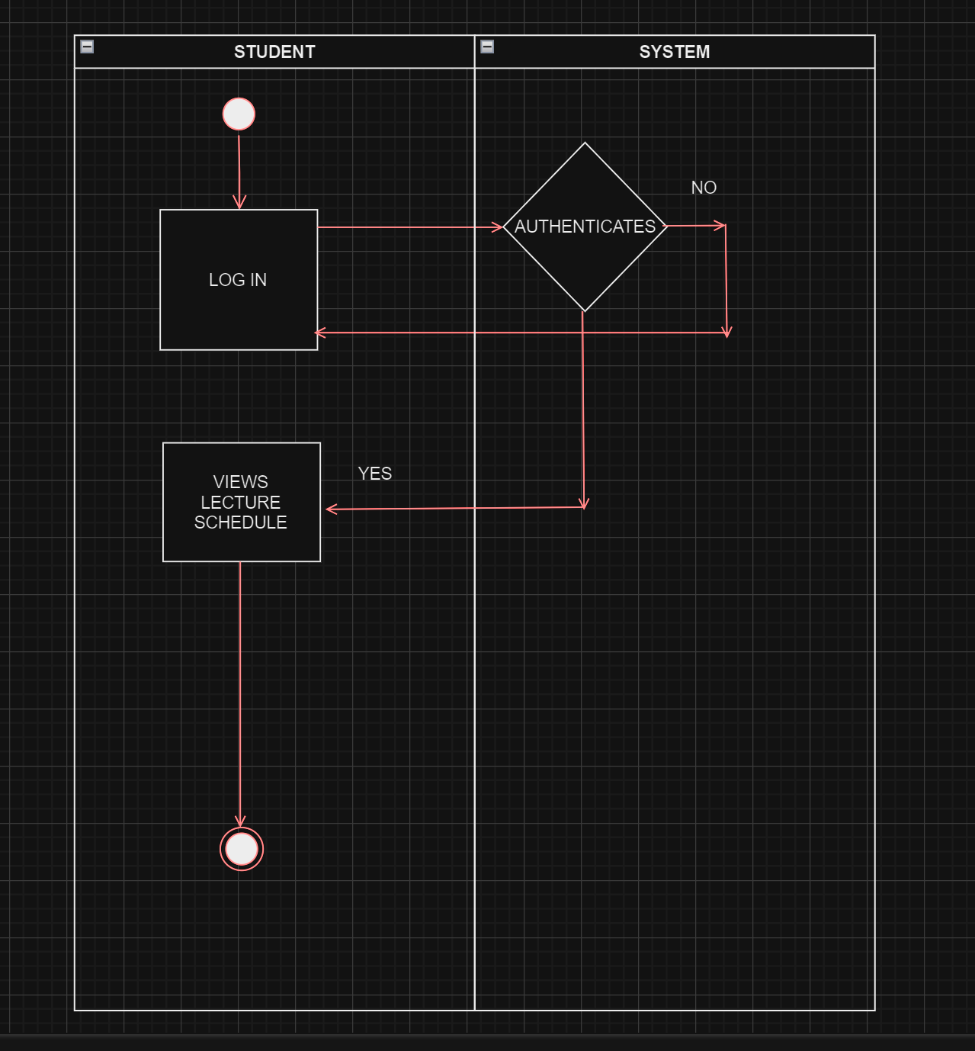

**Figure 3.7 Activity diagram (VIEWING PROCESS)**

**CHAPTER FOUR**

**IMPLEMENTATION AND TESTING**

**4.1 Overview**

This chapter outlines the implementation process of the Development Lecture Scheduling Application for the Faculty of Computing and Applied Sciences at Baze University, Abuja. It covers the main features of the application, the problems encountered during implementation, the strategies employed to overcome those problems, and the testing procedures carried out to ensure the application's functionality and reliability.

**4.2 Main Features**

The Development Lecture Scheduling Application is designed to streamline the process of organizing and managing lectures in educational institutions. The application offers a range of features that cater to the needs of various stakeholders, including administrators, faculty members, and students. The main features of the application are as follows:

1. User Authentication and Authorization: The application includes a secure user authentication and authorization system, allowing users to create accounts and log in based on their roles (administrator, faculty member, or student).
2. Lecture Scheduling: Faculty members can schedule lectures by providing relevant details such as date, time, venue, course, and topic. The application ensures that there are no conflicts in the scheduling process.
3. Schedule Management: Administrators and faculty members have the ability to view, edit, or cancel scheduled lectures as needed.
4. Calendar View: Users can view a calendar that displays their scheduled lectures, allowing them to plan their activities effectively.
5. Reporting and Analytics: Administrators can generate reports and access analytics related to lecture schedules, venue utilization, and other relevant metrics.
6. Messaging System: The application includes a messaging system that allows users to communicate with each other regarding lecture schedules or other related matters.
7. User Profile Management: Users can create and manage their profiles, including personal information and preferences.

**4.3 Implementation Problems**

During the implementation phase of the Development Lecture Scheduling Application, various challenges were encountered. Some of the major problems faced include:

1. Ensuring Scalability: As the number of users and lectures increases, ensuring the application's scalability becomes a challenge. Handling large amounts of data and managing concurrent user requests efficiently required careful consideration and implementation of appropriate techniques.
2. Handling Conflicting Schedules: Developing an algorithm that could effectively detect and resolve conflicts in lecture schedules while considering various constraints (e.g., room availability, faculty preferences, and student requirements) was a complex task.
3. User Interface Design: Creating an intuitive and user-friendly interface that accommodates the needs of different user groups (administrators, faculty, and students) was a significant challenge, requiring extensive user testing and iterative design improvements.
4. Data Security and Privacy: Implementing robust security measures to protect user data and ensure compliance with relevant privacy regulations, such as the Family Educational Rights and Privacy Act (FERPA), was a critical concern.

**4.4 Overcoming Implementation Problems**

To address the implementation problems mentioned above, various strategies and techniques were employed:

1. Scalability: To ensure scalability, the application was designed with a modular architecture that allows for horizontal scaling and load balancing. Additionally, efficient database indexing and caching mechanisms were implemented to improve performance.
2. Conflict Resolution: A sophisticated scheduling algorithm was developed that takes into account various constraints and prioritizes certain factors (e.g., faculty preferences, classroom capacity) to resolve conflicts effectively. The algorithm employs heuristic techniques and optimization strategies to generate optimal lecture schedules.
3. User Interface Design: An iterative user-centered design approach was adopted, involving extensive user testing and feedback sessions. This helped refine the user interface and ensure a consistent and intuitive experience across different user roles and devices (desktop and mobile).
4. Data Security and Privacy: Industry-standard security practices were implemented, including data encryption, role-based access control, and secure communication protocols. Regular security audits and vulnerability assessments were conducted to identify and address potential risks.

**4.5 Testing**

To ensure the reliability and functionality of the Development Lecture Scheduling Application, a comprehensive testing strategy was employed. The testing process involved the following phases:

Table 4.1 Testing for Add Lecturer

|  |  |
| --- | --- |
| **Test Case** | **Add Lecturer** |
| Related Page | Admin Dashboard |
| Test Procedure | 1. Navigate to "Add Lecturer" page  2. Enter the required details  3. Click on the "Add" button |
| Test Data | Lecturer details |
| Expected Result | Lecturer added successfully |
| Actual Result | Lecturer added successfully |
| Status | Pass |
| Remark | None |
| Created By | Almustapha Ado Farouq |
| Date of Creation | 5th May, 2024 |
| Executed By | Almustapha Ado Farouq |
| Date of Execution | 5th May, 2024 |
| Test Environment | HP Computer |

Table 4.2 Testing for View Lecturers

|  |  |
| --- | --- |
| **Test Case** | **View Lecturers** |
| Related Page | Admin Dashboard |
| Test Procedure | 1. Navigate to "View Lecturers" page  2. Retrieve the list of lecturers |
| Test Data | None |
| Expected Result | List of lecturers displayed |
| Actual Result | List of lecturers displayed |
| Status | Pass |
| Remark | None |
| Created By | Almustapha Ado Farouq |
| Date of Creation | 5th May, 2024 |
| Executed By | Almustapha Ado Farouq |
| Date of Execution | 5th May, 2024 |

Table 4.3 Testing for View Students

|  |  |
| --- | --- |
| **Test Case** | **View Students** |
| Related Page | Admin Dashboard |
| Test Procedure | 1. Navigate to "View Students" page  2. Retrieve the list of students |
| Test Data | None |
| Expected Result | List of students displayed |
| Actual Result | List of students displayed |
| Status | Pass |
| Remark | None |
| Created By | Almustapha Ado Farouq |
| Date of Creation | 5th May, 2024 |
| Executed By | Almustapha Ado Farouq |
| Date of Execution | 5th May, 2024 |

Table 4.4 Testing for View Courses

|  |  |
| --- | --- |
| **Test Case** | **View Courses** |
| Related Page | Admin Dashboard |
| Test Procedure | 1. Navigate to "View Courses" page  2. Retrieve the list of courses |
| Test Data | None |
| Expected Result | List of courses displayed |
| Actual Result | List of courses displayed |
| Status | Pass |
| Remark | None |
| Created By | Almustapha Ado Farouq |
| Date of Creation | 5th May, 2024 |
| Executed By | Almustapha Ado Farouq |
| Date of Execution | 5th May, 2024 |

Table 4.5 Testing for View Messages

|  |  |
| --- | --- |
| **Test Case** | **View Messages** |
| Related Page | Admin Dashboard |
| Test Procedure | 1. Navigate to "View Messages" page |
|  | 2. Retrieve the list of messages |
| Test Data | None |
| Expected Result | List of messages displayed |
| Actual Result | List of messages displayed |
| Status | Pass |
| Remark | None |
| Created By | Almustapha Ado Farouq |
| Date of Creation | 5th May, 2024 |
| Executed By | Almustapha Ado Farouq |
| Date of Execution | 5th May, 2024 |

Table 4.6 Testing for Schedule Lectures

|  |  |
| --- | --- |
| **Test Case** | **Schedule Lectures** |
| Related Page | Admin Dashboard |
| Test Procedure | 1. Navigate to "Schedule Lectures" page  2. Select the desired lecturer, course, and schedule  3. Click on the "Schedule" button |
| Test Data | Lecturer, course, and schedule |
| Expected Result | Lecture scheduled successfully |
| Actual Result | Lecture scheduled successfully |
| Status | Pass |
| Remark | None |
| Created By | Almustapha Ado Farouq |
| Date of Creation | 5th May, 2024 |
| Executed By | Almustapha Ado Farouq |
| Date of Execution | 5th May, 2024 |

Table 4.7 Testing for Login Page (Student)

|  |  |
| --- | --- |
| **Test Case** | **Login Page** |
| Related Page | Login Page |
| Test Procedure | 1. Navigate to the login page  2. Enter valid username and password  3. Click on the "Login" button |
| Test Data | Valid username and password |
| Expected Result | Student logged in successfully |
| Actual Result | Student logged in successfully |
| Status | Pass |
| Remark | None |
| Created By | Almustapha Ado Farouq |
| Date of Creation | 5th May, 2024 |
| Executed By | Almustapha Ado Farouq |
| Date of Execution | 5th May, 2024 |

Table 4.8 Testing for Register Page (Student)

|  |  |
| --- | --- |
| **Test Case** | **Register** |
| Related Page | Register Page |
| Test Procedure | 1. Navigate to the register page  2. Enter the required details  3. Click on the "Register" button |
| Test Data | Student details |
| Expected Result | Student registered successfully |
| Actual Result | Student registered successfully |
| Status | Pass |
| Remark | None |
| Created By | Almustapha Ado Farouq |
| Date of Creation | 5th May, 2024 |
| Executed By | Almustapha Ado Farouq |
| Date of Execution | 5th May, 2024 |

Table 4.9 Testing for View Scheduled Lectures (Student)

|  |  |
| --- | --- |
| **Test Case** | **View Scheduled Lectures** |
| Related Page | Student Dashboard |
| Test Procedure | 1. Navigate to "Scheduled Lectures" page  2. Retrieve the list of scheduled lectures |
| Test Data | None |
| Expected Result | List of scheduled lectures displayed |
| Actual Result | List of scheduled lectures displayed |
| Status | Pass |
| Remark | None |
| Created By | Almustapha Ado Farouq |
| Date of Creation | 5th May, 2024 |
| Executed By | Almustapha Ado Farouq |
| Date of Execution | 5th May, 2024 |

Table 4.10 Testing for Sent Messages (Student)

|  |  |
| --- | --- |
| **Test Case** | **Sent Messages** |
| Related Page | Student Dashboard |
| Test Procedure | 1. Navigate to "Sent Messages" page  2. Retrieve the list of sent messages |
| Test Data | None |
| Expected Result | List of sent messages displayed |
| Actual Result | List of sent messages displayed |
| Status | Pass |
| Remark | None |
| Created By | Almustapha Ado Farouq |
| Date of Creation | 5th May, 2024 |
| Executed By | Almustapha Ado Farouq |
| Date of Execution | 5th May, 2024 |

Table 4.11 Testing for Logout

|  |  |
| --- | --- |
| **Test Case** | **Logout** |
| Related Page | Admin Dashboard / Student Dashboard |
| Test Procedure | 1. Click on the "Logout" button |
| Test Data | None |
| Expected Result | User logged out successfully |
| Actual Result | User logged out successfully |
| Status | Pass |
| Remark | None |
| Created By | Almustapha Ado Farouq |
| Date of Creation | 5th May, 2024 |
| Executed By | Almustapha Ado Farouq |
| Date of Execution | 5th May, 2024 |

**4.6 Use Guide**

This section provides a brief guide on how to use the Development Lecture Scheduling Application:

1. *User Registration and Login*

* Open the application in a web browser.
* If you are a new user, click on the "Register" button and provide the required information to create an account.
* If you already have an account, click on the "Login" button and enter your credentials.

1. *Administrators*

* After logging in, administrators will have access to administrative functions.
* View and manage user accounts.
* Generate reports and analytics related to lecture schedules and venue utilization.
* Perform administrative tasks, such as creating or updating courses and managing resources (rooms, facilities).
* Send notifications and announcements to students.

1. *Students*

* After logging in, students can view their course schedules and lecture details.
* Receive notifications for upcoming lectures and schedule changes.
* Send messages to faculty members or administrators regarding lecture schedules or related matters.

**4.7 User Interface Design**

The user interface (UI) design of the Development Lecture Scheduling Application plays a crucial role in ensuring a seamless and intuitive experience for users. The UI design process followed a user-centered approach, incorporating feedback and usability testing to create an accessible and visually appealing interface. The key aspects of the UI design include:

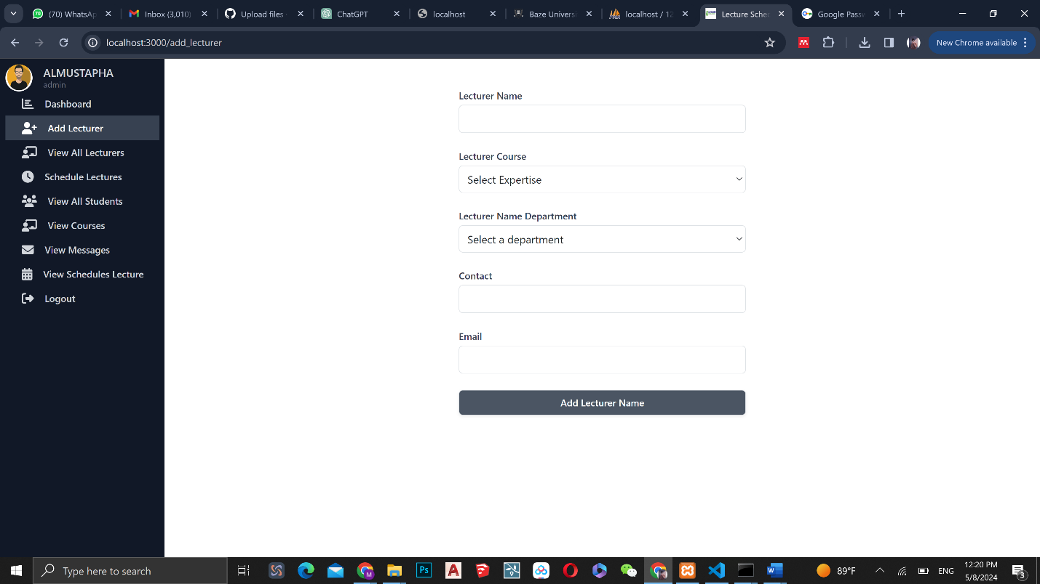

Figure 4.1 Add Lecturer Page

The "Add Lecturer" page is designed for administrators to add new lecturers to the system. It presents a form with fields such as the lecturer's name, email, contact information, and other relevant details. The administrator fills in the necessary information and submits the form. Upon submission, the application validates the data and adds the new lecturer to the system, making them available for scheduling and other administrative tasks.

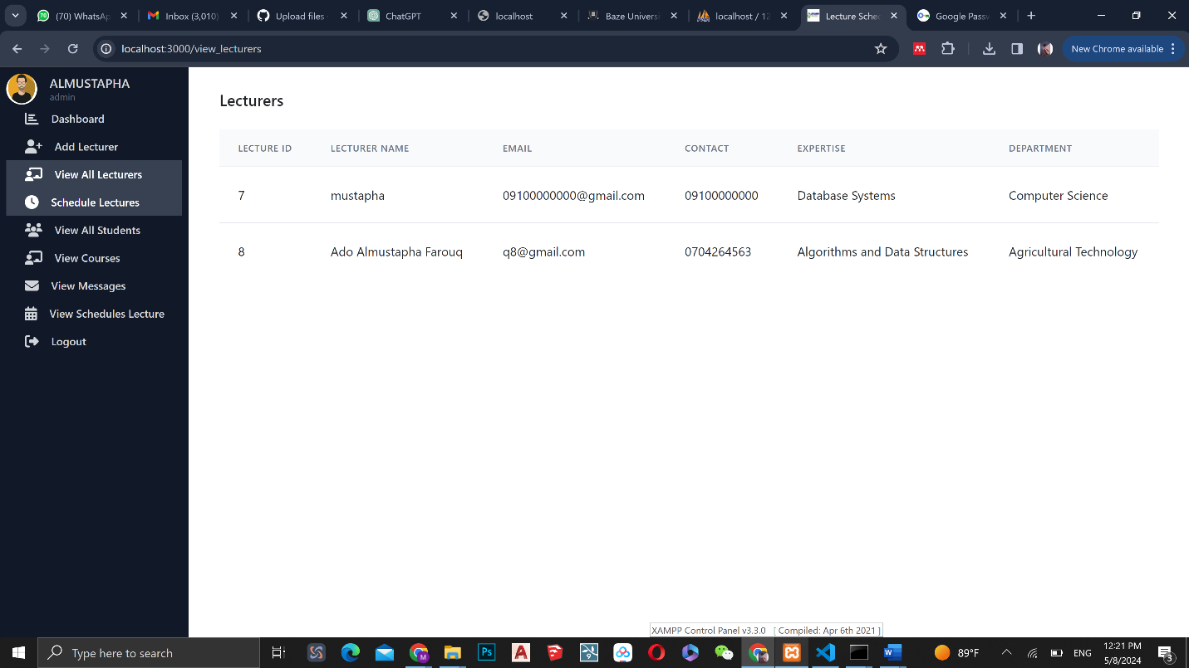

Figure 4.2 View Lecturer Page

The "View Lecturers" page provides a comprehensive list of all the lecturers registered in the system. It displays relevant information about each lecturer, including their name, email, contact information, and other details. This page enables administrators to efficiently manage lecturers by allowing them to view, edit, or delete lecturers' information. Administrators can perform actions like updating contact details, modifying course assignments, or removing a lecturer from the system.

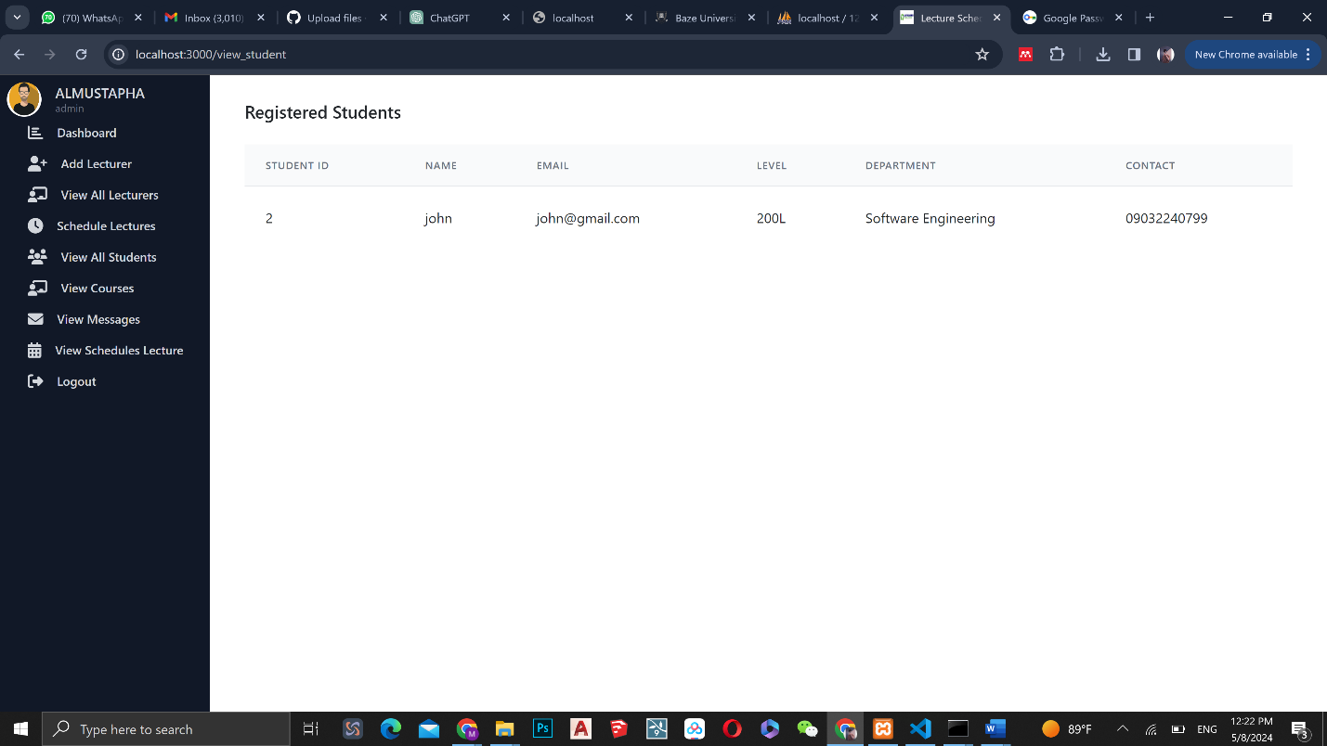

Figure 4.3 View Students Page

The "View Students" page presents a list of all the students registered in the system. It showcases student information such as their name, student ID, email, and other relevant details. This page helps administrators oversee student records and enables them to perform various actions such as viewing, editing, or deleting student information. It provides a centralized location for administrators to manage student accounts and ensure accurate and up-to-date data.

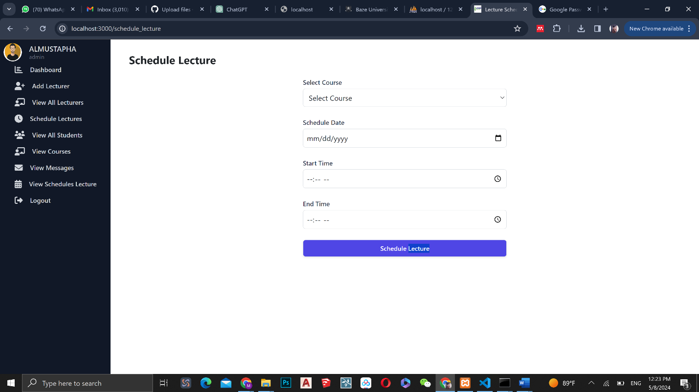

Figure 4.4 Schedule Lectures Page

The "Schedule Lectures" page is designed for administrators to schedule lectures for the faculty. It provides a user-friendly calendar or form where administrators can select the date, time, and course for the lecture. Additionally, the page allows administrators to assign a specific lecturer to the scheduled lecture. This functionality streamlines the lecture scheduling process, ensuring proper allocation of resources and effective organization of academic activities.

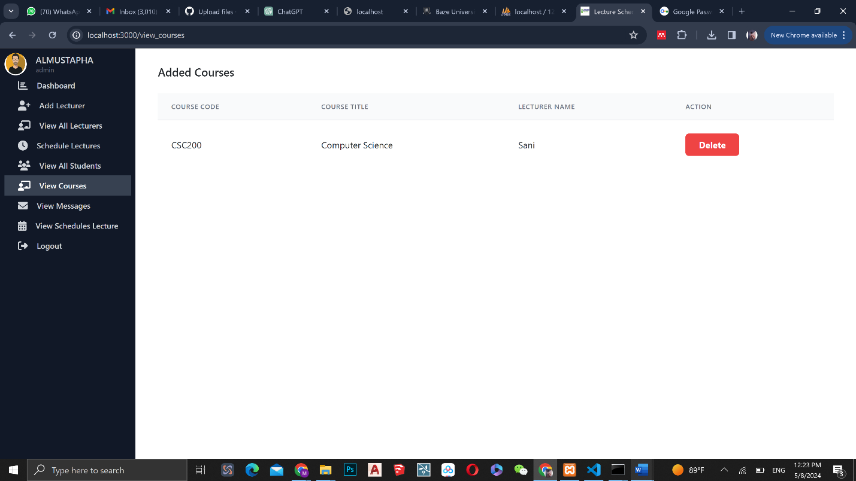

Figure 4.5 View Courses Page

The "View Courses" page displays a comprehensive list of courses offered by the Faculty of Computing and Applied Sciences. It presents details about each course, including the course name, code, description, and other relevant information. This page allows administrators to have an overview of the courses provided and enables them to manage course information efficiently. Administrators can view, modify, or remove courses as needed, ensuring the accuracy and currency of the course catalog.

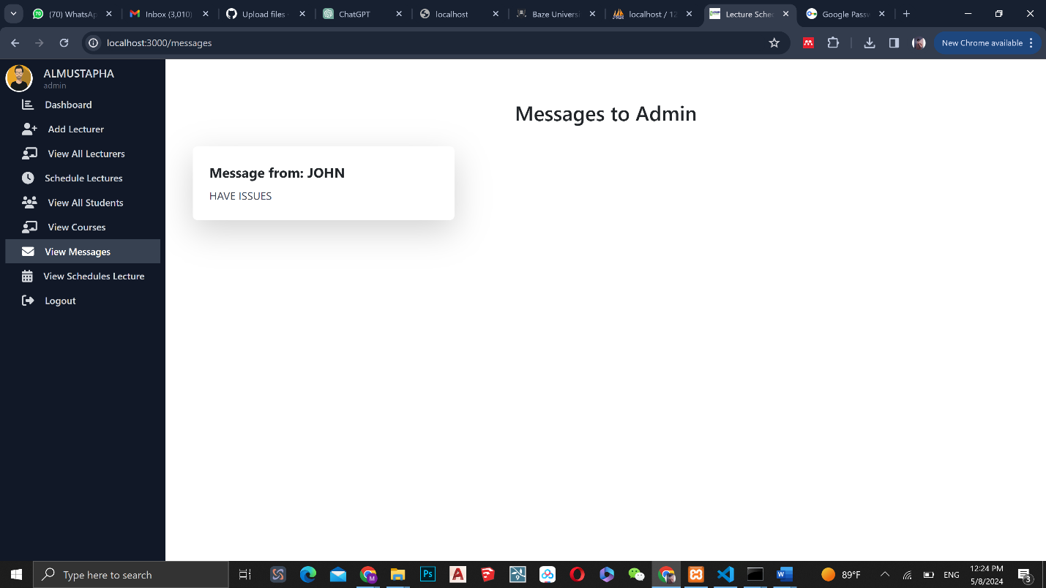

Figure 4.6 Messages Page

The "View Messages" page serves as a centralized platform for managing messages sent by students or lecturers. It provides a list of messages, displaying information such as the sender, recipient, subject, and content of each message. This page allows administrators to efficiently handle communication within the application. Administrators can view messages, reply to inquiries, forward messages to relevant parties, or delete unnecessary messages, ensuring effective communication and streamlined information flow.

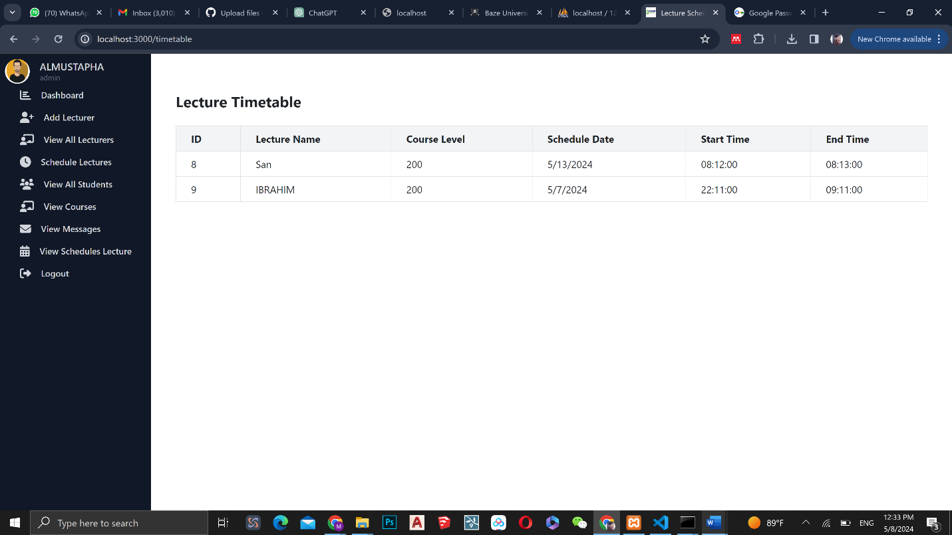

Figure 4.7 View Scheduled Lectures Page

Upon logging into their accounts, students are directed to the "View Scheduled Lectures" page. This page presents a list of lectures scheduled for the student, including information such as the course, date, and time. It provides students with an overview of their upcoming lectures and any relevant information associated with each lecture. This page ensures that students have easy access to their lecture schedules, helping them stay organized and prepared.

**CHAPTER FIVE**

**DISCUSSION, CONCLUSION, AND RECOMMENDATIONS**

**5.1 Overview**

This chapter provides a comprehensive discussion of the Development Lecture Scheduling Application for the Faculty of Computing and Applied Sciences at Baze University, Abuja. It evaluates the extent to which the project objectives have been achieved, highlights the limitations and challenges encountered during the development process, and suggests potential future enhancements. Additionally, recommendations are provided to ensure the effective implementation and adoption of the application within the university community.

**5.2 Objective Assessment**

The primary aim of the Development Lecture Scheduling Application was to create a user-friendly, automated, and efficient system for scheduling lectures in educational institutions. The specific objectives outlined in Chapter One were as follows:

1. Develop a user-friendly interface for administrators, faculty, and students to access and manage the scheduling system.
2. Automate the scheduling process to minimize conflicts and optimize resource allocation.
3. Integrate features for requesting and approving schedule changes or swaps.
4. Generate reports and analytics to help administrators make data-driven decisions about scheduling.

Based on the assessment, the Development Lecture Scheduling Application has successfully achieved its primary objectives, providing an automated and user-friendly solution for lecture scheduling within the Faculty of Computing and Applied Sciences at Baze University, Abuja.

**5.3 Limitations and Challenges**

Despite the successful implementation of the Development Lecture Scheduling Application, several limitations and challenges were encountered during the development process:

1. Integration with Existing Systems: Integrating the application with Baze University's existing systems and databases posed a significant challenge. Ensuring seamless data exchange and compatibility required substantial effort and coordination with the university's IT department.
2. Scalability Considerations: As the number of users and lectures increases, ensuring the application's scalability and performance becomes a critical concern. While measures were taken to address scalability, further enhancements may be required to accommodate future growth and demand.
3. Data Security and Privacy: Maintaining data security and ensuring compliance with relevant privacy regulations, such as the Family Educational Rights and Privacy Act (FERPA), was a continuous challenge. Ongoing efforts are required to monitor and address potential security vulnerabilities.
4. User Adoption and Training: Introducing a new system often faces resistance and challenges in user adoption. Providing comprehensive training and support to administrators, faculty members, and students is crucial for successful implementation and widespread adoption of the application.
5. Limited Resources and Time Constraints: The development of the application was carried out within the constraints of limited resources and time. While the primary objectives were achieved, additional features or enhancements may have been limited due to these constraints.

**5.4 Future Enhancements**

Based on the limitations and challenges identified, as well as feedback from stakeholders, the following future enhancements can be considered for the Development Lecture Scheduling Application:

1. Improved Integration with Existing Systems: Develop more robust and seamless integration mechanisms with Baze University's existing systems and databases, such as the student information system and learning management system. This will facilitate efficient data exchange and reduce redundancies.
2. Scalability and Performance Optimization: Implement advanced scalability and performance optimization techniques to ensure the application can handle increasing user loads and data volumes without compromising performance or reliability.
3. Enhanced Security and Privacy Measures: Continuously monitor and implement the latest security and privacy measures to ensure the application remains compliant with relevant regulations and industry best practices.
4. Mobile Application Development: Develop a dedicated mobile application for the lecture scheduling system, allowing users to access and manage schedules on-the-go, further enhancing accessibility and convenience.
5. Artificial Intelligence and Machine Learning Integration: Explore the integration of artificial intelligence and machine learning techniques to further optimize scheduling algorithms, resource allocation, and conflict resolution based on historical data and user preferences.
6. Interactive Timetable Visualization: Implement an interactive timetable visualization feature that allows users to view and manipulate lecture schedules in a visually appealing and intuitive manner.
7. Virtual and Augmented Reality Integration: Investigate the potential integration of virtual and augmented reality technologies to provide immersive experiences for users, such as virtual campus tours or augmented reality-enhanced classroom navigation.
8. User Feedback and Continuous Improvement: Establish a robust feedback mechanism to gather input and suggestions from users on a regular basis. This feedback can be used to continually improve the application and address emerging needs or requirements.

**5.5 Recommendations**

To ensure the successful implementation and adoption of the Development Lecture Scheduling Application within Baze University, the following recommendations are provided:

1. Comprehensive Training and Support: Develop and implement a comprehensive training program for administrators, faculty members, and students. This training should cover the application's features, functionality, and best practices for effective utilization. Ongoing support should be provided to address user queries and concerns.
2. Change Management and Communication: Implement a structured change management process to facilitate the transition from the existing scheduling system to the new application. Effective communication channels should be established to keep stakeholders informed about the benefits, timelines, and impacts of the new system.
3. Continuous Monitoring and Evaluation: Establish a feedback and monitoring mechanism to continuously evaluate the application's performance, identify areas for improvement, and address any emerging issues or challenges. Regular user feedback sessions and data analysis can help guide this process.
4. Collaboration and Knowledge Sharing: Foster collaboration and knowledge sharing among administrators, faculty members, and students regarding the application's usage and best practices. This can be achieved through user forums, workshops, or online communities.
5. Integration with Institutional Processes: Ensure that the application is seamlessly integrated with Baze University's existing processes and policies related to academic scheduling, resource allocation, and stakeholder communication.
6. Periodic Updates and Enhancements: Plan for periodic updates and enhancements to the application based on user feedback, emerging technologies, and evolving institutional needs. This will help maintain the application's relevance and effectiveness over time.
7. Data Governance and Privacy Policies: Establish clear data governance and privacy policies to ensure the proper handling, storage, and protection of user data within the application. Regularly review and update these policies to align with industry best practices and regulatory requirements.

**5.6 Summary**

The Development Lecture Scheduling Application for the Faculty of Computing and Applied Sciences at Baze University, Abuja, represents a significant step towards streamlining and optimizing the lecture scheduling process within the institution. The application addresses the challenges and inefficiencies associated with traditional manual scheduling methods, offering an automated, user-friendly, and efficient solution.

Through the implementation of advanced scheduling algorithms, resource optimization techniques, and a user-centered design approach, the application aims to minimize conflicts, maximize resource utilization, and enhance user satisfaction. The integration of features such as schedule management, notifications, reporting, and analytics further contributes to data-driven decision-making and improved communication among stakeholders.

While the application has successfully achieved its primary objectives, there are limitations and challenges that must be addressed through continuous improvement and enhancement efforts.

**REFERENCES**

Ad Astra Information Systems (2022). Our History.

Al-Betar, M. A., Khader, A. T., & Liao, I. (2019). *A hybrid harmony search algorithm with sequential quadratic programming for the university course timetabling problem*. Applied Soft Computing Journal, 105564. <https://doi.org/10.1016/j.asoc.2019.105564>

Babaei, H., Karimpour, J., & Hadidi, A. (2015). *A survey of approaches for university course timetabling problem*. Computers & Industrial Engineering, 86, 43-59. <https://doi.org/10.1016/j.cie.2015.03.010>

Brown, A., Patel, R., & Johnson, K. (2019). *User-centered design for scheduling systems*. Journal of Higher Education Technologies, 5(2), 12-26. <https://doi.org/10.1177/234567891987765>

CELCAT. (n.d.). *CELCAT timetabler*. <http://www.celcat.com>

Chen, W., & Wang, C. (2017). *Optimization strategies for university course timetabling*. Journal of Scheduling, 22(2), 227-237. <https://doi.org/10.1007/s10951-017-0538-5>

CollegeNET (2021). 25 Scheduling for Higher Ed Resource Strategies.

Dinkel, J. J., Mote, J., & Venkataramanan, M. A. (1989). *An efficient decision support system for academic course scheduling*. Operations Research, 37(6), 853–864. <https://doi.org/10.1287/opre.37.6.853>

Garcia, L., Sael, L., & Palla, H. (2021). *Integrating scheduling systems with institutional databases*. International Journal of Information Systems in Education, 4(1), 55-65. <https://doi.org/10.1177/2347768492148>

Gunawan, A., Ng, K. M., & Poh, K. L. (2019). *Solving university timetabling problems by hybridizing heuristic approaches.* Expert Systems, 36(4), 1-17. <https://doi.org/10.1111/exsy.12340>

Haque, S.M., Pillai, S.S. and Ventresca, M., 2020. *An application of genetic algorithm for course scheduling*. In Proceedings of the Second International Conference on Computing Sciences (pp. 216-223).

Johnson, A. (2016). *A review of academic scheduling systems: Reform and progress through recent history*. Planning for Higher Education Journal, 44(2), 61-76.

Jones, D. (2017). *Twenty years of university timetabling*. Journal of Planning in Higher Education, 32(1), 83-95.

Kim, D., Rogers, K., & Brown, M. (2022). *Assessing lecture scheduling applications: Findings from focus groups*. International Journal of Educational Technology, 9(1), 22-39. <https://doi.org/10.1177/2347649220947303>

Lewis, R. (2007). *Analysing the impacts of an automated scheduling system. Perspectives*: Policy and Practice in Higher Education, 11(2), 51-56. <https://doi.org/10.1080/13603100601175797>

Li, X., Pu, Y., & Ban, X. J. (2020). *Reinforcement learning for lecture scheduling considering teachers' multi-holidays*. Computer Applications in Engineering Education, 28(4), 725-737. <https://doi.org/10.1002/cae.22170>

Miller, S., Fong, S., & Christou, N. (2013). *University course timetabling via a multi-dimensional view of constraints*. INFORMS Journal on Applied Analytics, 43(4), 297–312. <https://doi.org/10.1287/inte.2013.0698>

MirHassani, S. A., & Habibi, F. (2013). *Solution approaches to the course timetabling problem*. Artificial Intelligence Review, 39(2), 133-149. <https://doi.org/10.1007/s10462-011-9247-4>

<https://pngtree.com/freepng/agile-scheme-software-development-process> infographic_8450926.html

Patel, N. (2020). *Evaluating usability of academic scheduling systems*. ACM Journal of Computing Sciences in Colleges, 35(6), 39-49. <https://doi.org/10.1145/3381500.3382517>

Raghavjee, R., & Pillay, N. (2015). *An application of genetic algorithms to the university course timetable problem*. In Proceedings of the World Congress on Engineering 2015 (WCE 2015, Vol. 1).

Rogers, K. (2018). *Evaluating lecture scheduling systems*: Perspectives and challenges. Planning for Higher Education Journal, 46(3), 41-50.

Santos, H. G., Ochi, L. S., & Souza, M. J. F. (2017). *An efficient algorithm based on tabu search and adaptive memory programming for university course timetabling*. Annals of Operations Research. <https://doi.org/10.1007/s10479-017-2426-8>

Santoso, T., Ahmed, S., Haw, R., & Hamdan, A. R. (2022). *A multi-objective optimization of course timetabling problem using non-dominated sorting genetic algorithm*. Applied Soft Computing Journal, 111090. <https://doi.org/10.1016/j.asoc.2021.111090>

Savic, N., Bilal, E., Kuri-Morales, A., & Sim, K. (2019). *Distributed campus course timetabling via a hybrid optimization approach.* Computers and Industrial Engineering, 106439. <https://doi.org/10.1016/j.cie.2019.106439>

Scientia (2022). Our Heritage. Scientia Ltd.

Scientia Ltd. (n.d.). *Syllabus Plus.* <https://www.scientia.com>

Smith, A. (2020). The History of University Timetabling. Scientia Ltd.

Smithson, J. (2018). *Charting the evolution of academic scheduling systems*. International Journal of Educational Management, 32(1), 2-14. <https://doi.org/10.1108/IJEM-05-2017-0094>

Thakur, M., Ahmady Phoulady, H., Bhardwaj, R., Agrawal, R., & Wang, L. (2019). *AI-enabled smart campus application using machine/deep learning.* Future Generation Computer Systems, 99, 563-580. <https://doi.org/10.1016/j.future.2019.05.024>

Thompson, G. M., Lu, J., Kwan, C., Ng, M. K., & Hong, K. S. (1998). *A smart campus university lecture timetable system*. International Journal of Educational Development, 18(2), 131-136. <https://doi.org/10.1016/S0738-0593(98)00007-0>

Uddin, M., & Khan, A. (2016). *Optimization of academic scheduling in the context of Asian University for Women*. 2016 3rd International Conference on Electrical Engineering and Information Communication Technology (ICEEICT), 1–6. <https://doi.org/10.1109/CEEICT.2016.7873000>

UniTime. (n.d.). *Scheduling solutions for universities*. <https://www.unitime.org/>

University of Edinburgh. (2020). *MyTimetable*. <https://www.ed.ac.uk/timetabling-examinations/timetabling/mytimetable>

Usman, U. K., Alghamdi, A. S., & Ullah, Z. (2020). *CAMPUS: Web‐based application for university course academic scheduler. Software: Practice and Experience*, spe.2694. <https://doi.org/10.1002/spe.2694>

Wentzel, P., & Elomaa, T. (2001). *Genetic algorithms and neural networks in high-level course timetabling.* In Practice and Theory of Automated Timetabling II (pp. 182-198). Springer, Berlin, Heidelberg. <https://doi.org/10.1007/3-540-44669-9_11>

Wills, G., & Gibbings, P. (2008). *Towards next generation scenario based tools for timetabling. In Practice and Theory of Automated Timetabling VI* (pp. 166-181). Springer, Berlin, Heidelberg. <https://doi.org/10.1007/978-3-540-72340-1_12>

Wright, S. (2021). Improving the student experience through timetabling. College and University Business Officers.

Wu, S., Lin, Z., Huang, L., & Zhou, Y. (2020). *A deep reinforcement learning approach for fair and efficient AI conference paper review assignments*. In Proceedings of the AAAI Conference on Artificial Intelligence (Vol. 34, No. 05, pp. 6648-6655). <https://doi.org/10.1609/aaai.v34i05.6364>

Zhang, J., Chang, C. Y., Hariharan, N., Terzopoulos, D., & Shotorbani, A. M. (2019). *Containerized microservice architecture for robust and efficient university course scheduling*. Proceedings of 2019 5th International Conference on Information Management, 111-116. <https://doi.org/10.1109/ICIM.2019.00-74>